1. Approach the power control screen. If it is all black (off) wave your hand in front. It is motion activated. It should look like this. Press ‘Start’

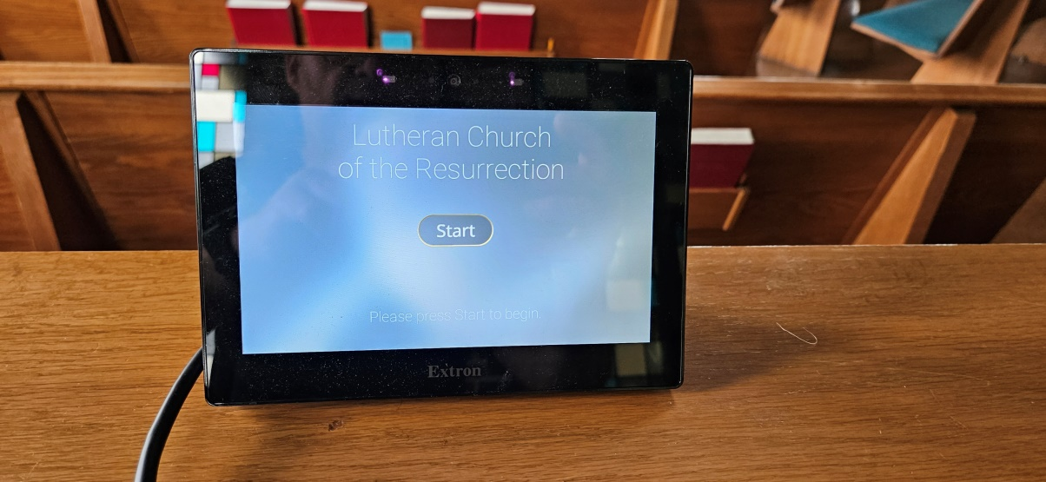

1. Select Power Options:  
   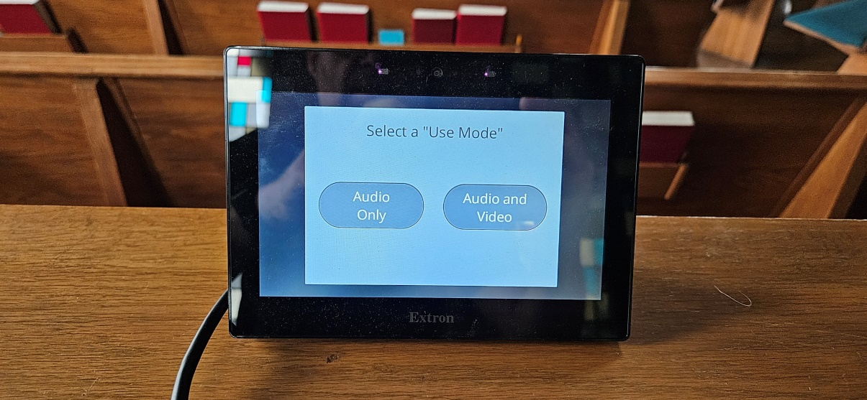

**For 10:00 Service**

**(or If Projector is needed)**

**For 8:00 Service**

**(or if NO Projector is needed)**

1. Screen will look like this: (If ‘Audio Only’ was selected above, Projector will be ‘Off’)  
   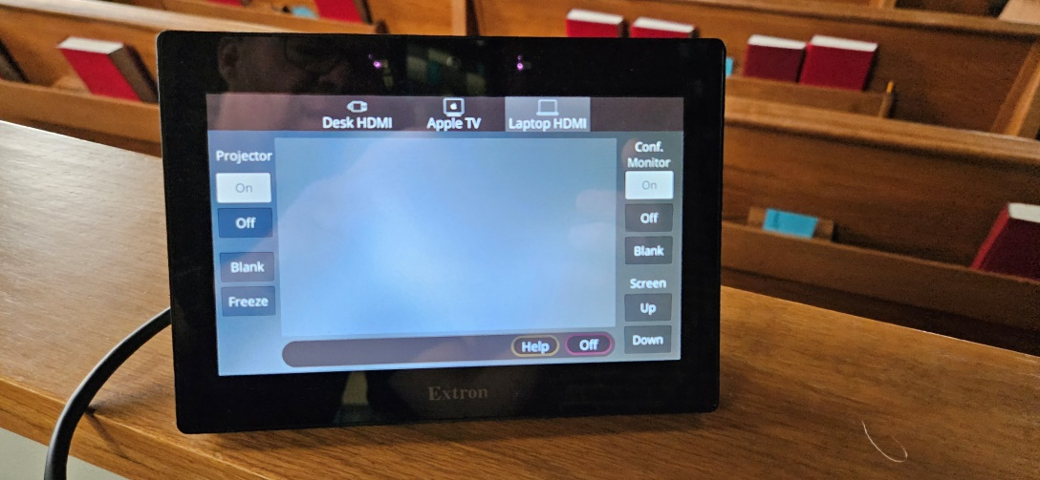
2. The sound board will look like this. The screen is a touch screen.  
   Press the ‘Scenes’ button:

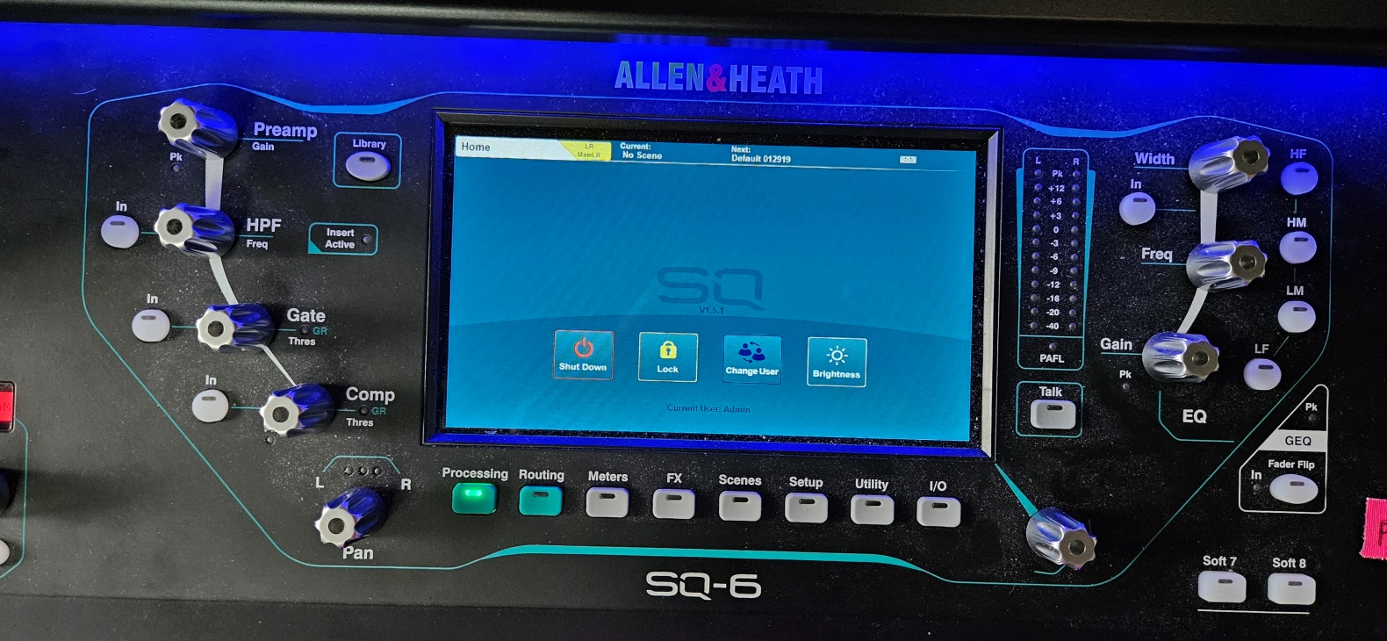

**Press ‘Scenes’ Button**

1. From the Scenes screen, select the desired scene:  
   1. 8 AM  
   2. 10AM New Stream (for normal 10am service with Lynette/Fred band  
   3. 10AM Alt Band (for 10am service with Jake/Emily or other band

**Select Scene**

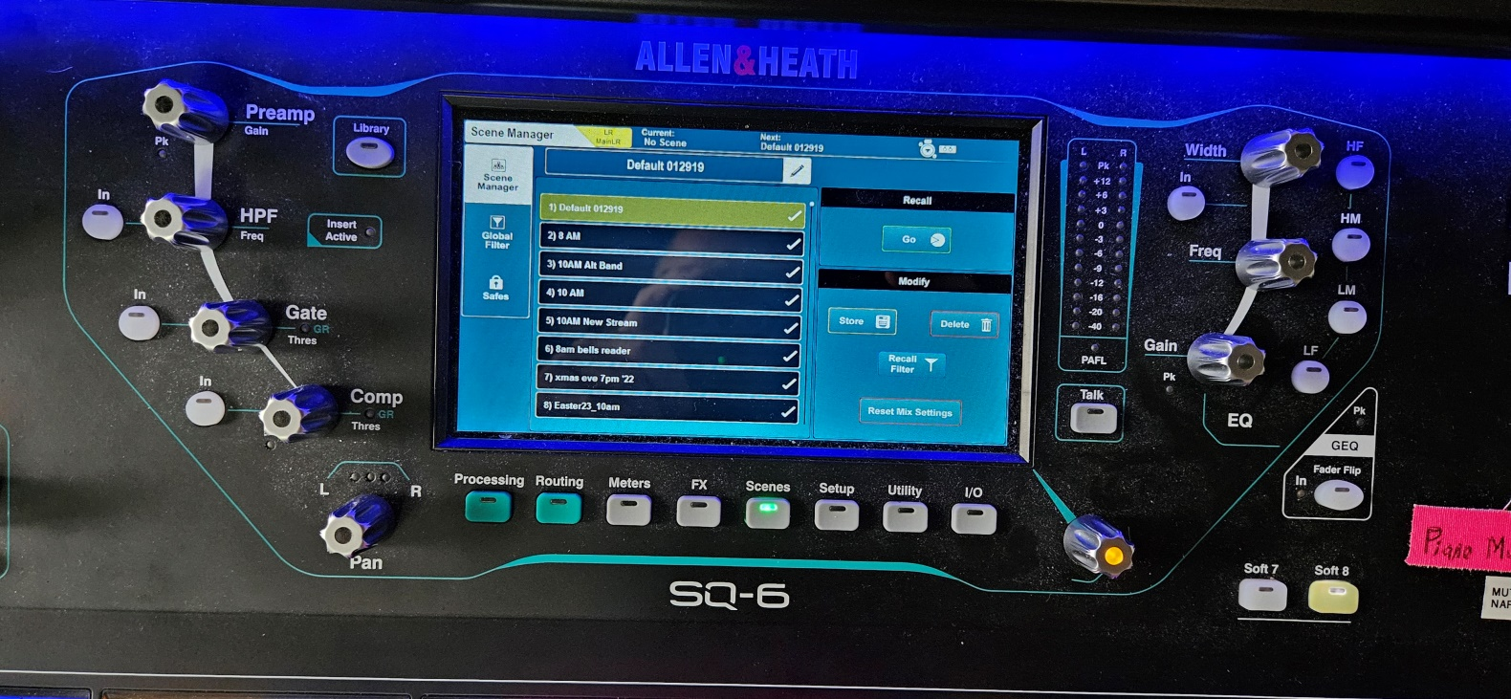

**Press ‘Yes’ to recall the selected scene**

**Under ‘Recall’  
Press ‘Go’**

1. On the lower left of sound board, press the ‘**F**’ layer key. This will bring up the most often used sliders.
2. On the right side, blue ‘LR’ button should be lit blue. If not press ‘LR’ button. Blue buttons 1-12 should be off. This means sliders will be controlling the sound in the sanctuary.  
     
     
     
     
   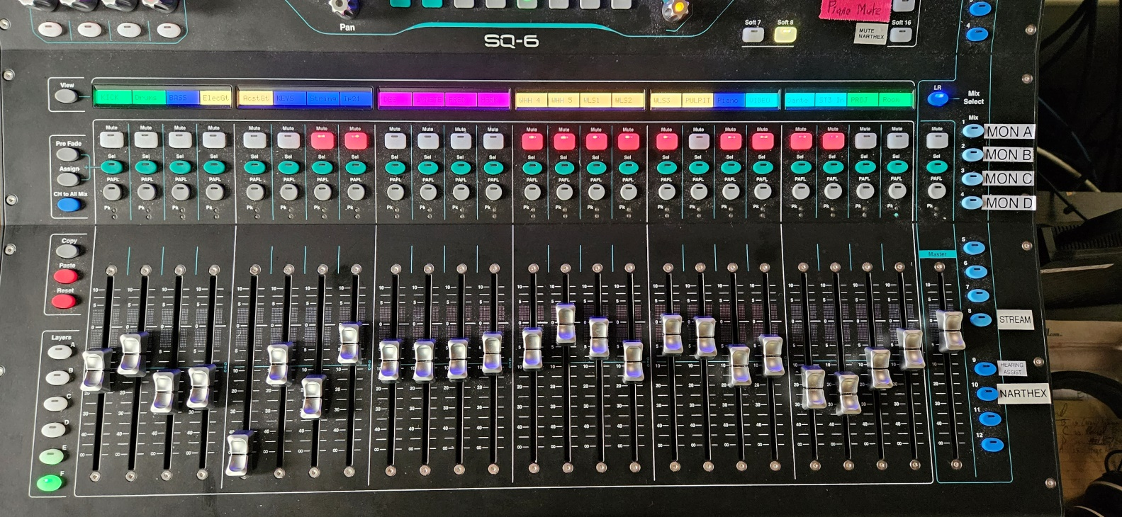

**Channel Labels**

**Press the ‘F’ Layer button**

**Blue buttons change control to other areas**

**MUTE indicator lights:**

* **LIT is MUTED**
* **UNLIT is LIVE**

**‘LR’ lit blue**

**Channel Sliders**

**Layers (show varied channel labels)**

1. The sound levels should be pretty much set, with SLIGHT adjustment as needed. *Pastor John may need to be turned down a bit.
2. Microphones:
   1. ‘**WLS**’ 1,2,3 are the **W**ire**L**es**S** mics used with headset/lavalier (clip-on), usually used by the pastor.
   2. ‘**WHH**’ 4,5 are the **W**ireless **H**and **H**eld mics usually used by special speakers.
   3. For both types of mics:
      1. Setup:
         1. Check mic unit power level when it is still plugged into rack.
         2. If using a lavalier mic, clip it in the vertical middle of the person, no lower than approx. 3 inches from their chin. DO NOT clip on collars on the side of their face or chin.
         3. Power unit may be clipped anywhere, with cord appropriately hidden.
      2. After setting them up and turning OFF the mic, find the channel for the mic, UNmute the mic channel.
      3. Have the person turn OFF the mic until they need it. THE USER IS IN CONTROL OF WHEN THE MIC IS ON OR OFF with the mic power switch!
         1. IF THEY FORGET TO TURN THEIR MIC OFF, you may mute it, and pay attention to unmute it if they go to use it again.
         2. *Especially* for Hand Held mics COACH the person to hold the mic close to their mouth!
      4. Return:
         1. Turn OFF mics and **gently** place in chargers. Tilt the WLS units slightly back as you put it in. This helps to keep the charger pins from being bent and un-usable.
         2. Wrap the headset or lavalier and place back in pouch.
3. Hearing assist devices:
   1. Are the numbered packs in separate charger. They need to be turned on and earpiece plugged in. Earpieces are interchangeable. *User can control volume with dial on top.*
      1. Roger Knutson has a labled earpiece for him.
      2. Return devices to charger and place earpiece in baggie.
4. Common sliders A slider should never be all the way to the top. General rule of thumb: keep slider levels below 0.
   1. BEWARE of feedback! If you hear feedback, IMMEDIATELY lower the slider.

|  |  |
| --- | --- |
| **Channel Label** | **Description/Action** |
| Pulpit | If the person at the pulpit mic is too far away, raise the slider. If too loud lower the slider. BEWARE OF FEEDBACK! |
| WLS(#) and WHH(#) Wireless mics | Very dependent on user. BEWARE OF FEEDBACK if adjusting! |
| ‘Fred’ (by stage right keyboards), ‘Lynette’ (center, by main keyboard), ‘Dee’ (stage left) | Mics for band singers |
| ‘Inst | Generally furthest stage left, could be anywhere. Sometimes used for an additional instrument like violin or horn. Can be source of feedback, mute it if not in use. |
| Bass | The bass player can control their volume. May need some adjustment at the board. |
| Piano | Center band keyboards. Keyboard player can control their own volume. May need some adjustment at the board. |
| INP20 | Grand Piano mic. Should be used if livestreaming so livestream gets piano sound. Can be very low in ‘LR’ as sound will naturally carry. |
| INP21 | Singer/Flute mic by grand piano. |